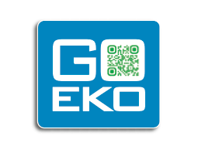

Contact us

A Swiss company

The connexion to efficiency

The Green Transition. Easy. Fast. Affordable.

**Download White Paper**

|  |
| --- |
| **First Name:** |
| **Last name:** |
| **Company:** |
| **Email:** |

Don’t worry! We respect your privacy.

**SMEs**

You suffer from **3 pains?** Energy costs increase, clients pressure to go green and new regulations.

GoEko has the **best solutions for you**.

First benefit: You can **reduce your environmental impact**

Second benefit: You can **increase your profitability**

Third benefit: You can **beat your competitors**

**Cleantech**

You run a cleantech company.

You have **3 difficulties?** Get new customers, open new markets and marketing costs increase.

GoEko has the **best** **solutions for you**.

First benefit: You can get **qualified leads**

Second benefit: You can open **new markets**

Second benefit: You can **reduce marketing costs**